Apply filters to SQL queries

Project description
Filter with AND, OR, and NOT

Retrieve after hours failed login attempts
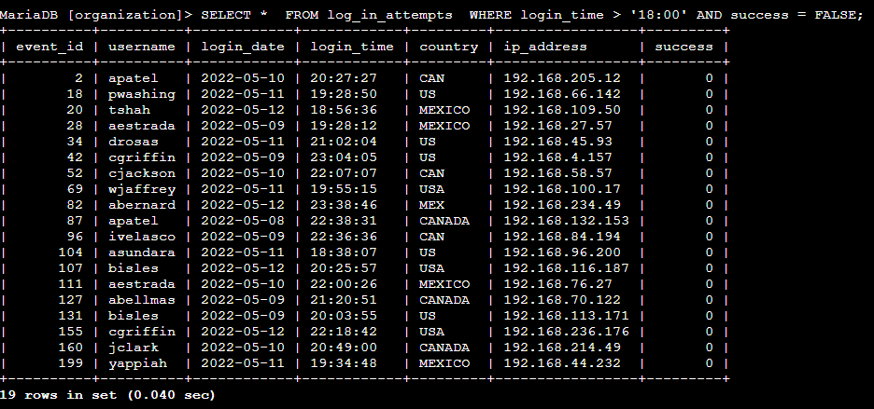

.

Retrieve login attempts on specific dates
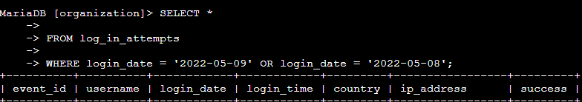



Retrieve login attempts outside of Mexico
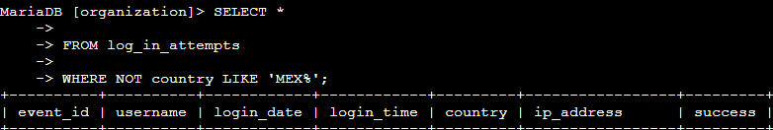

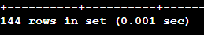

Retrieve employees in Marketing
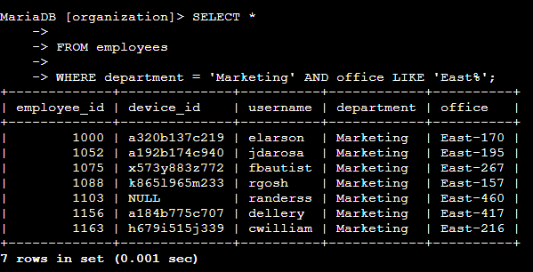

Retrieve employees in Finance or Sales
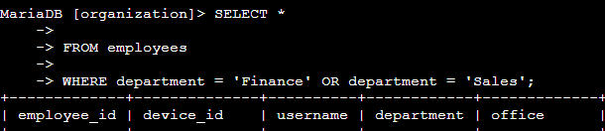[Add content here.]

Retrieve all employees not in IT

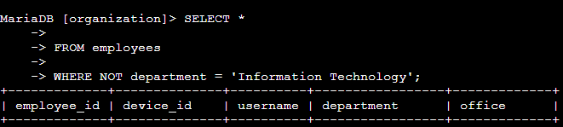

Summary
After going through each SQL queries to retrieve information from a database and apply AND, OR, and NOT operators to filter SQL queries the applied filters helped accomplish the task from the employee table and going through each column.

What to Include in Your Response
Be sure to include the following in your completed activity:
- Screenshots of your queries or typed versions of the queries
- Explanations of your queries
- A project description at the beginning
- A summary at the end
- Details on using LIKE to search for a pattern
- Details on filtering for dates and times
- Details on using AND and OR to filter on multiple conditions
- Details on using NOT in filters

